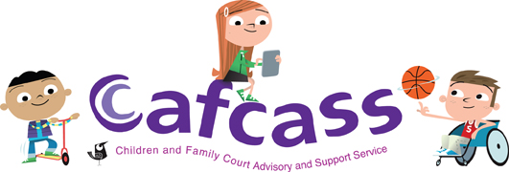

Board Meeting Agenda
Wednesday, 7 July 2021, 13:00 to 15:30
Zoom

 | BUSINESS MEETING (Cafcass Board, CMT, FJYPB AND moj)  The Zoom call will open at 12.50 for Board, CMT, FJYPB and MOJ to convene in preparation for Stakeholder being given access to the meeting at 13.00 | 13.00 – 15.30
 | Introduction from the Chair  1.1 Welcome and apologies  1.2 Declarations of interest  1.3 Minutes, actions and matters arising | 13.00 – 13.10
 | Chief executive officer’s REPORT  Jacky Tiotto, Chief Executive Officer | 13.10 – 14.10
 | Family Justice Young People’s Board Report  FJYPB representatives | 14.10 – 14.30
 | Break | 14.30 – 14.40
 | People and Organisational Development Strategy  Adam Bowles, Interim Head of HR and Organisational Development  Julie Brown, Director of Resources | 14.40 – 15.00
 | REPORTS FROM COMMITTEES (ORAL ITEM):  Helen Jones, Chair of the Audit and Risk Assurance Committee  Paul Grant, Chair of the Performance and Quality Committee  Catherine Doran, Chair of the People Committee | 15.00 -– 15.15
FINANCE REPORT (WITHIN CHIEF EXECUTIVE OFFICER’S REPORT)
Julie Brown, Director of Resources
 | Close and any other business  Sally Cheshire, Chair | 15.15 – 15.30

Date and time of the next meeting: Wednesday, 20 October 2021

