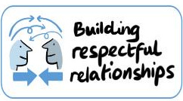
Significant Others’ Feedback Form
Child’s Name: | ChildFirst Ref Number:
What is your role in this child’s life?

☐ ☐ ☐ ☐ ☐
How satisfied are you that the Family Court Advisor or Child’s Guardian helped this family?

Please tell me how the Family Court Advisor or Child’s Guardian made a difference? What were the most helpful things they did?
Add your comments:

What could they have done better?
Add your comments:

